Ideation Phase

Define the Problem Statements

|  |  |
| --- | --- |
| Date | 19 September 2022 |
| Team ID | PNT2022TMID41904 |
| Project Name | IOT BASED SAFETY GADGET FOR CHILD SAFETY  MONITORING AND NOTIFICATION. |
| Maximum Marks | 4 Marks |

**Customer Problem Statement:**

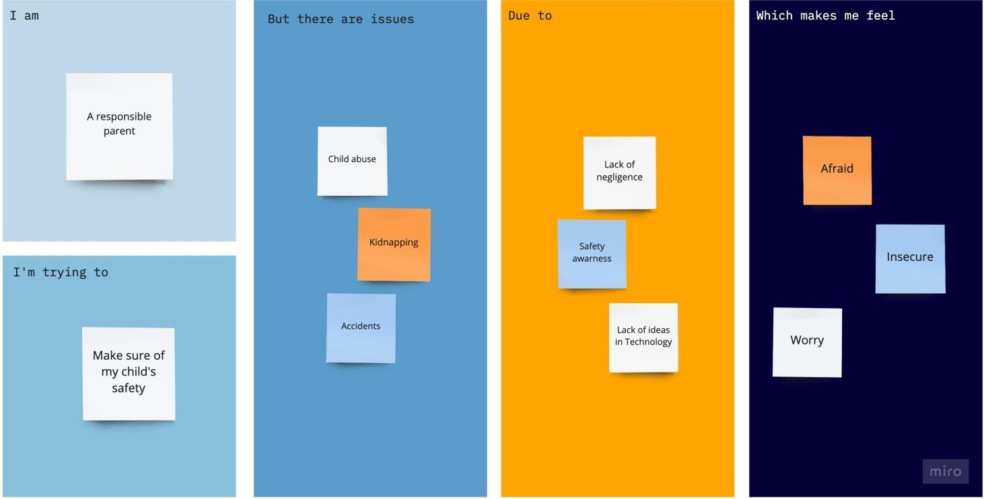

|  |  |  |  |  |  |
| --- | --- | --- | --- | --- | --- |
| **Problem Statement (PS)** | **I am (Customer)** | **I’m trying to** | **But** | **Because** | **Which makes me feel** |
| PS-1 | A  responsible parent | Make sure of my child’s safety | Child  abuse | Lack of  negligence | Afraid |
| Accidents | Safety awareness | Insecure |
| kidnapping | Lack of ideas  in technology | Worry |